
a

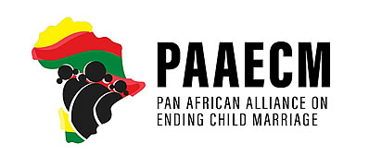

FACILITATION REPORT YOUTH-LED DIGITAL ADVOCACY CONVENING

HELD AT SAT, LUSAKA
6th – 7th August, 2026

Facilitated by
Taonga Zulu

TABLE OF CONTENT
ACRONYMS 3

EXECUTIVE SUMMARY 4

1.0 INTRODUCTION AND BACKGROUND 5

2.0 PARTICIPANTS OF THE CONVENING 5
⁠
3.0 WORKSHOP PROCEEDINGS 5

3.1 METHODOLOGY AND MENTIMETER BASELINE ASSESSMENT 5

3.2 OPENING SESSION AND CONTEXT SETTING 5

3.3 WORKSHOP OBJECTIVES AND EXPECTED OUTPUTS AND
ROADMAP 6

3.4 TECHNICAL PRESENTATION ON THE SADC MODEL LAW 6

3.5 COUNTRY-LEVEL MAPPING AND ADVOCACY BRIEF LAB 6

3.6 YOUTH LEADERSHIP PANEL ON MOVEMENT BUILDING 6

3.7 DIGITAL SAFETY, HYGIENE, AND NARRATIVE STRATEGY 7

3.8 STRATEGY LABS AND CAMPAIGN DESIGN 7

3.9 GALLERY WALK PITCH SESSION AND ACTION ROADMAP 8

4.0 KEY OUTCOMES, RECOMMENDATIONS AND WAY FORWARD 9

5.0 CLOSING SESSION AND NEXT STEPS 9

6.0 CONCLUSION 9

7.0 PICTURE GALLERY 10

APPENDICES

APPENDIX 1: PROGRAMME

APPENDIX 2: LIST OF PARTICIPANTS

ACRONYMS

CSO Civil Society Organization

FGDs Focus Group Discussions

PAAECM Pan African Alliance on Ending Child Marriage

SADC Southern African Development Community

SRHR Sexual and Reproductive Health and Rights

EXECUTIVE SUMMARY

The Pan African Alliance on Ending Child Marriage (PAAECM), convened a two-day regional hybrid training workshop in Lusaka, Zambia. Designed for youth leaders, civil society organization (CSO) representatives, and human rights defenders working on ending child marriage, the convening targeted a critical systemic problem: the widening gap between progressive regional legislative frameworks, specifically the SADC Model Law on Eradicating Child Marriage and Protecting Children Already in Marriage and local, grassroots implementation. The workshop blended technical legal literacy training with advanced digital campaign design, equipping young advocates with the practical tools required to hold duty-bearers accountable, counter systemic pushback, and drive structural policy reform.

- INTRODUCTION AND BACKGROUND

The regional convening was conceptualized to address the persistent implementation deficit surrounding child marriage laws in Southern Africa. Despite the existence of progressive regional standards, young advocates frequently encounter traditional, institutional, and socio-economic roadblocks at the community level. This workshop provided a dedicated space to bridge technical legal knowledge with grassroots digital activism, strengthening cross-border collaboration among youth networks.

2.0 PARTICIPANTS OF THE CONSULTATION WORKSHOP
⁠A total of 15 participants attended the convening, the convening brought together a specialized cohort of participants representing youth-led networks, and youths from civil society organizations. Attendees comprised youth advocates, and feminist organizers, committed to ending child marriage and advancing adolescent rights. The list of participants is attached to this report as Appendix 2.

3.0 WORKSHOP PROCEEDINGS

3.1 Methodology used to Deliver the Workshop
The Facilitator applied interactive and participatory methods of facilitation to ensure that all participants were actively engaged in the discussions during the workshops. Deliberations were restricted to smaller groups to provide a chance to all participants to partake in the discussions. To encourage detailed discussions, more time during the workshop was allocated to group work. The Facilitator provided clear instructions for each work assigned to the groups. Leaders of the groups were instructed to allow participants to contribute freely on any topic that was under discussion. Each group assigned a note taker, to ensure that all conversations were captured. Every presentation was followed by a plenary session giving chance to participants to ask questions, clarify points and provide perspective on topics under discussion.

Furthermore, to evaluate participant readiness and baseline knowledge, interactive digital polling (Mentimeter) was administered at the start of the convening.
- Results indicated that 2 participants were extremely familiar with the SADC Model Law, 3 were somewhat familiar, 4 had very little familiarity, and 4 were not familiar at all.
- Regarding digital safety, 9 participants reported feeling very confident, 3 fairly confident, and 2 not confident.
- Eight were comfortable with social media graphics and rapid-response tweetstorms led communication strategies followed by three non-users who were unaware, two of the participants were able to generate short-form videos for advocacy, with zero participants having utilized podcasts or webinars.
- Post the convening, 7 participants felt very confident and 4 felt fairly confident in translating legal concepts into advocacy messaging all participants developed confidence in having knowledge on the SADC Model law.

3.2 Opening Session and Context Setting

The opening session established an intersectional human rights-based framework, connecting macro-level regional instruments to the lived realities of girls across the SADC region. Facilitators emphasized the urgency of shifting regional strategies from mere legislative adoption to rigorous enforcement, grassroots accountability, and structural protection for vulnerable adolescents. After the formal opening session, the Facilitator led participants into an interactive introductory session intended to break the ice and improve the mood of the workshop.

3.3 Presentation on the Objectives and Expected Outputs of the Consultation Workshop and Strategic Plan Development Roadmap

Facilitator outlined the core objectives of the two-day convening:
- Build shared technical mastery of the SADC Model Law on Eradicating Child Marriage and Protecting Children Already in Marriage,
- Strengthen youth-led movement building and digital advocacy capacity to accelerate progress towards ending child marriage.

3.4 Technical Presentation on the SADC Model Law
The technical deep dive unpacked the twin pillar architecture of the SADC Model Law:
- The first pillar, focused on establishing an absolute, minimum marriage age of 18 without exception, alongside robust criminal sanctions for perpetrators, facilitators, and complicit adults.
- The second pillar that examined state obligations to guarantee the continuation of education for pregnant girls and adolescent mothers, provide comprehensive SRHR services, and establish specialized psychosocial support systems for survivors.

3.5 Country-Level Mapping and Advocacy Brief Lab
Working groups conducted comparative legal audits cross-referencing national statutes against the SADC Model Law. Teams identified loopholes such as customary law exemptions and weak birth registration systems. Participants translated statutory articles into targeted, one-page advocacy briefs tailored for parliamentary portfolio committees.

3.6 Youth Discussion on Movement Building
The Facilitator divided participants in groups to discuss the situational analysis and context of the organisation. To guide their discussions, the Facilitator instructed participants to consider interrogating the external macro-environmental factors and internal organisational capacities. The Facilitator guided participants to discuss external macro environmental factors such as political and legal factors; economic and social trends; as well as technological shifts. For internal factors, and encouraged participants to explore decentralized network models, horizontal accountability, and cross-border coalition building. Discussions centred on overcoming political co-optation, maintaining grassroots autonomy, and ensuring meaningful youth participation in national policy formulation.

Group Work Report Back
The following was the report back by the groups:

Movement Building Pillars & Frameworks
- Sustainable movements rely on four core pillars, a shared vision and narrative uniting diverse groups, distributed leadership across decentralized networks, strategic cross-sector coalitions, and sustained mobilization balancing events with daily organizing.
- Social movements differ fundamentally from traditional campaigns by aiming for generational cultural and power transformations rather than short-term legislative adjustments, utilizing decentralized community-led structures instead of hierarchical staff management.

Youth-Led Action & Grassroots Strategy
- Youth advocates drive change by pinpointing specific legislative gaps (such as age exceptions and customary law conflicts), mobilizing peer networks to engage duty-bearers, and executing synchronized digital campaigns.
- Real transformation requires bridging regional policy frameworks with villages through grassroots community actions that empower local champions including traditional leaders and parents to challenge harmful social norms from within.

Digital Advocacy & Activist Sustainability
- Digital storytelling and platforms allow youth advocates to bypass traditional media gatekeepers, transforming passive online awareness into active legislative accountability through hashtags, petitions, and real-time updates.
- Protecting activist well-being and preventing burnout requires prioritizing mental health support systems, rotating leadership tasks to accommodate personal and professional lives, and regularly celebrating milestones.

3.7 Digital Safety, Hygiene, and Narrative Strategy
This session addressed the psychological and physical security risks associated with digital human rights advocacy. Advocates received practical training in secure digital hygiene, metadata scrubbing, encrypted communication protocols, and framing compelling human rights narratives that protect sources from retaliation.

3.8 Strategy Labs and Campaign Design
Participants were divided into groups and directed to discuss and propose digital campaign designs and strategies. The participants were guided to refer to all work done earlier on the situational analysis and context.

Participants co-designed digital campaigns combining creative arts, storytelling, and rapid-response messaging. Teams mapped target audiences, core messaging arcs, timeline milestones, and risk-mitigation protocols for their respective campaigns.

Group Work Report Back
The following suggestions and strategies:

Youth-Led Digital Advocacy Strategies
- Pinpoint Legislative Gaps: Identify precise loopholes in local statutes such as age exceptions, customary law conflicts, or enforcement failures to target specific, actionable policy shifts.
- Engage Duty-Bearers: Mobilize peer networks and community mentors to formulate evidence-based advocacy demands directed specifically at legislators, line ministries, and traditional leaders.
- Execute Creative Arts & Storytelling: Utilize digital platforms to bypass traditional media gatekeepers, sharing authentic stories, real-time updates, and creative multimedia content directly with regional policymakers and global allies.
- Deploy Rapid-Response Messaging: Coordinate synchronized digital campaigns, rapid-response tweetstorms, and social media graphics to broadcast legislative realities, rally public pressure, and demand immediate accountability.

Digital Campaigns
- Develop online campaigns and visual content to broadcast legislative realities and rally public pressure via tweetstorms & social media graphics.
- Use digital platforms and social media to share real-time stories directly with regional policymakers and global allies.
- Combine digital petitions, hashtags, and creative multimedia narratives to transform passive online awareness into active legislative accountability.
- Define target audience segments and structure strategic messaging arcs that explicitly connect regional legal frameworks, such as the SADC Model Law, to the lived realities of adolescents.
- Use short-form video content to expand audience reach and deliver punchy, accessible human rights messages across digital networks.

Suggested Hashtags
- #My body is mine
- #Let her be child
- # Her body her choice
- #Vabukulu ni Vabukulu
- #Mutwela ai tule
- #Not at the moment
- #School is cool
- #Stay in school
- #Let me grow
- #Book not rings
- #Mwana ni Mwana
- #Real men build futures
- #Musiyeni mwana apuzile
- #Mulekeni asambilile
- #Books don't bite
- #SADC for Children

3.9 Gallery Walk Pitch Session and Action Roadmap
Teams presented their campaign concepts during an interactive gallery walk pitch session. Peer reviewers evaluated submissions based on feasibility, scalability, and human-rights alignment. Feedback was synthesized into a finalized 6-month regional action roadmap.

4.0 KEY OUTCOMES, RECOMMENDATIONS AND WAY FORWARD

The following key areas were captured as workshop recommendations:

Recommendations | - Finalize and Distribute Advocacy Outputs: Consolidate and circulate country-specific advocacy briefs to national parliamentary sub-committees and civil society steering groups.  - Institutionalize Digital Resilience: Integrate recurring digital security and data protection training into national youth network activities.  - Prioritize Grassroots Enforcement: Shift regional advocacy focus toward monitoring local implementation and budgetary allocation in rural districts where customary practices outpace statutory law.

5.0 CLOSING SESSION AND NEXT STEPS
The convening concluded with reflections from participants, evaluations, and the formal adoption of the regional action roadmap. Network leads outlined commitments for national-level follow-up actions and inter-country peer learning exchanges. The convening was officially closed by the Mr Nchayelela who thanked the participants for the dedication exhibited during the convening. He commended participants for the fruitful deliberations and applauded participants on their active participation.

6.0 CONCLUSION
The convening successfully bridged technical legal literacy with practical digital mobilization. By equipping youth advocates with deep knowledge of the SADC Model Law and advanced campaign tools, the workshop fortified a resilient regional movement dedicated to eradicating child marriage across Southern Africa.

7.0 PICTURE GALLERY
Pre-convening Survey
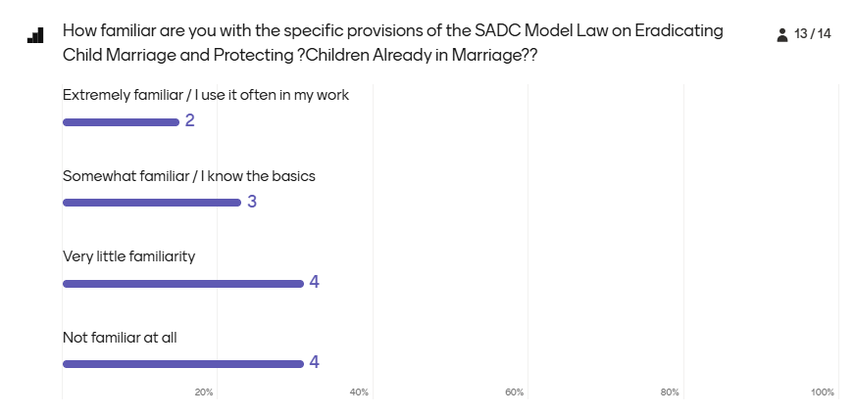

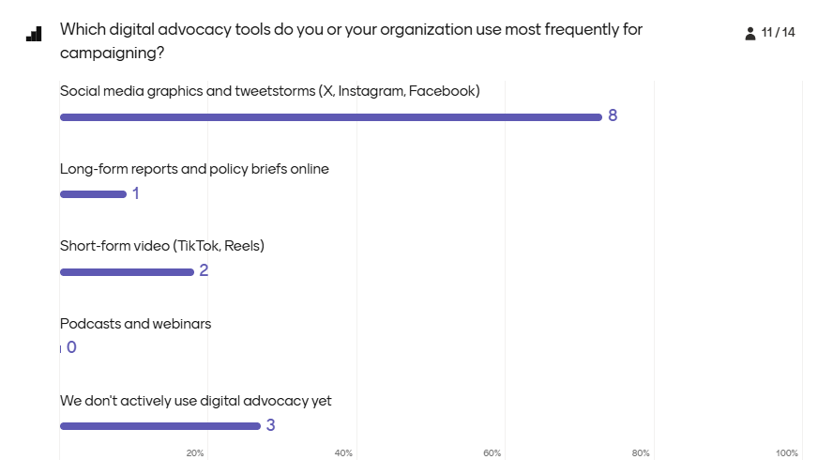

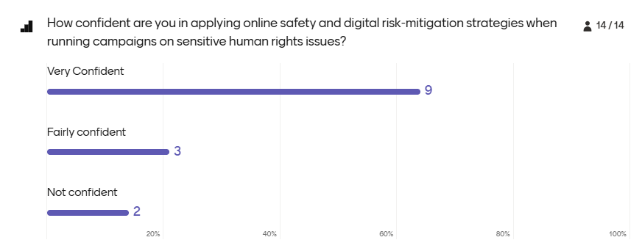
Menti during Convening
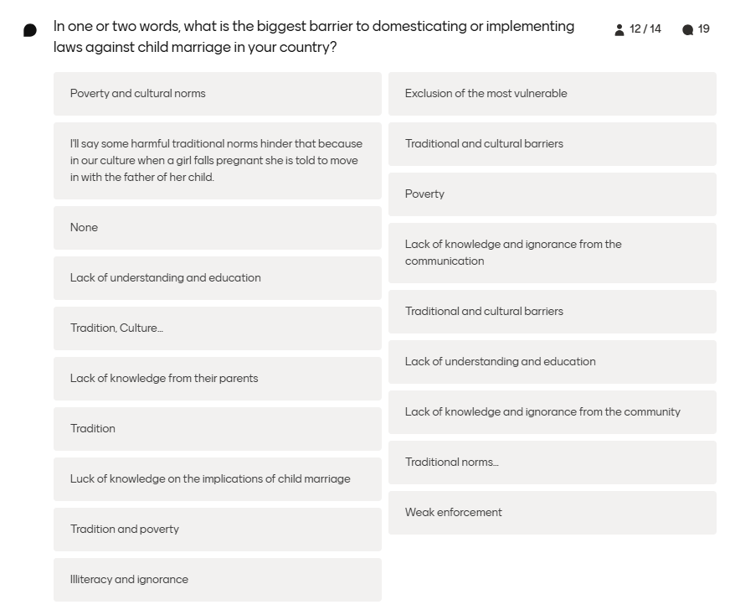

Post Convening Menti
Participants developed strong confidence translating law into advocacy suggests participants feel equipped to turn legal knowledge into demands. Near-universal confidence in youth-led digital campaigning suggests strong readiness for youth-centered advocacy.

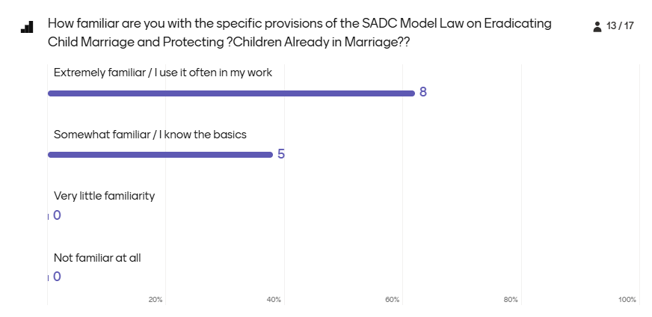
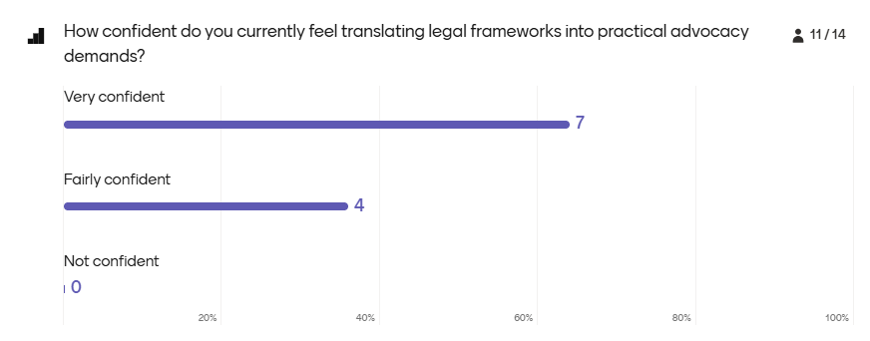

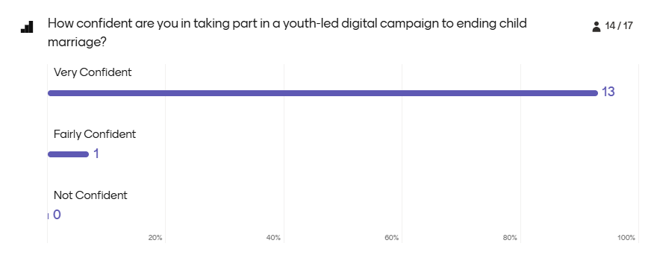

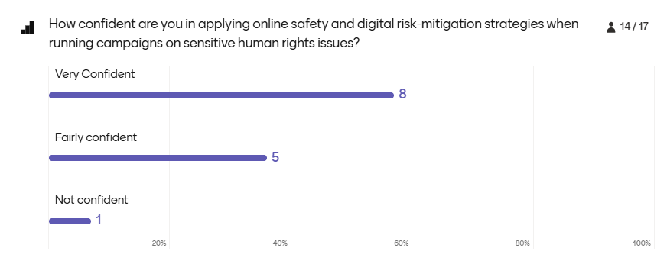

APPENDICES

Appendix 1: Programme
Day 1
08:30 | Registration and Arrival
09:30 | Official Opening & Welcome Remarks — PAAECM Secretariat
09:40 | Setting the Scene: Why the SADC Model Law Matters for Youth Advocacy (Menti survey)
10:00 | Deep Dive: Unpacking the SADC Model Law — Key provisions, domestication status, gaps, and youth-led advocacy
11.00 | Health break
11.15 | Domestication Status Breakout Groups: Mapping legal/policy environments, Children’s Code Act performance, wins, gaps, and protections for married children
13:00 | Lunch
14:00 | From Law to Practice: Plenary feedback from breakout groups using the Youth-Wise Study Kit
15:00 | Skills Session: Using the Model Law as an Advocacy Tool (Translating legal text into talking points and duty-bearer asks)
16:00 | Working Groups: Drafting a One-Page Model Law Advocacy Brief
16:40 | Report-Back & Plenary: Sharing group outputs and consolidating key themes
17:00 | Refreshments & Networking
Day 2
09:00 | Recap of Day 1 & Framing for Day 2
09:30 | Panel Discussion: What Makes a Youth Movement Powerful? (Lessons from existing regional youth-led movements)
10:30 | Health Break
10:45 | Movement Building Skills Session: Storytelling, Campaign Design & Safe Digital
11:45 | Breakout Groups: Movement-Building Strategy Labs (Covering coalition structure, decision-making, resourcing, and online safeguarding)
13:00 | Lunch
14:00 | Co-Design Session: Regional Digital Advocacy Campaign Concept (Linking Model Law asks with movement voices)
15:00 | Gallery Walk / Pitch: Campaign Concept Presentations & Menti Survey
16:00 | Roadmap: Setting 6-month commitments and digital advocacy strategies — PAAECM Secretariat
16:30 | Closing Ceremony & Way Forward — PAAECM Secretariat / host partner

Appendix 2: List of Participants

